**Submitted to:**

**Rezwan Ahmed**

assistant professor

Department of computer Science

American International University – bangladesh

**Submitted by:**

1. *Riyad , MD Ahsan Ferdous*

*ID:**15-29804-2*

1. Ahmed , Md ShaonID: 15-30027-2
2. Roy , Kamal KrishnaID: 15-29788-2
3. Saied , Ahmed FoyezID : 16-31496-1

**Section: G**

E-COmmerce website

Database Model

**Table of contents**

**Part - A**

1. Business and system summary ...................................................................................1
2. Business overview
3. Overview .............................................................................................2
4. Project Summary .................................................................................2
5. Technical summary of super shop management system database
6. List of Entities of the model .................................................................3
7. List of attributes of the model .............................................................3
8. List of constraints according to table....................................................3
9. SQL statement to create sample table and insert sample values ........4
10. Identifying objective & describing the database working
11. Users services ......................................................................................9
12. Administrator services .........................................................................9
13. Entity – Relationship diagram (ER Diagram) ...............................................................10
14. Normalization .............................................................................................................11
15. Relationship diagram ..................................................................................................12
16. Screenshots of the table with only data type of the attributes....................................13
17. Screenshot of the tables with sample data records ....................................................15
18. Demonstrating some database use scenarios and SQL queries...................................18
19. View creation of the table
20. Complex view ......................................................................................21
21. Simple view .........................................................................................22

**Part - B**

Summarizing learning experience from database project ..............................................24

* **Part - A**

**Business and system summary**

This ‘Super shop management database system’ will help a shop itself better and also help showing better service can a shop provide using this database system. It helps us to understand how a customer, salesman and product information is stored in a super shop information system, what types of products are taken by customer, how the system manages the relation with customer and salesman, how a product’s information are enlisted in the shop. How commissions are given to salesman are also provided by this system. The system also provides the total amount of shopping by a customer with goods information. Salesman are provided to assist customer to buy goods. Salesman can access into the system of super shop management by creating data into this system. It’s also provides financial records specific to a single component, or groups of components.

**Business overview**

**Overview:** Super shop management is primarily about specifying the size and placement of stocked goods. Super shop management is required at different locations within a facility or within multiple locations of a supply network to protect the regular and planned course of production against the random disturbance of running out of materials or goods.

The way super shop works is not very complicated. Shop has to be the capability to keep information about customer and employee. Shop, therefore, has the most important component and hence they are customer, employee, products and shop itself. Shop has a big collection of inventory. The inventory can contain different type of products.

But the most important thing about Shop is that the system can get much more complicated if it is not organized and thus, therefore, it is necessary to create a management system that can organize the data and help the shop to be organized and work properly.

**Project Summary:** Super shop management system is not really much complicated but the problem is having huge number of customer and there is so many new customer coming into the shop every day or week. Every customer has a separate identity. New employee may come to the shop and some employee may leave the shop.

The shop has so many products. The products have to be identified as product type. Salesman got commission by selling a fixed amount.

In every month there is a necessity to take summarizing of the sell to identify the profit and to keep up the information.

**Technical summary of super shop management system database**

The database system that prepared in this project can be accessed via a software program or a web-server based system using internet access or as an embedded data storage system. The database system and the project was made using Oracle SQL Express 11g, Microsoft Word. All the tables of entity and attributes were made using Oracle SQL Express 11g.The database system is very simple in design and to implement. This system requires very low system resources and this system will work in almost all configurations.

**List of Entities of the model:**

* Customers
* Orders
* Products
* Supplier
* Supply_Order
* Salesman
* Branch

**List of attributes of the model:**

* **Customer’s Attributes:**

|  |  |  |  |  |  |  |
| --- | --- | --- | --- | --- | --- | --- |
| **Attribute** | Name | ID | EMAIL | CITY | ADDRESS | MEM_SINCE |
| **Data Types** | VARCHAR2(30) | NUMBER(10) | VARCHAR2(30) | VARCHAR2(10) | VARCHAR2(300) | DATE |

* **Order’s Arrtibutes:**

|  |  |  |
| --- | --- | --- |
| **Attribute** | ID | DATE |
| **Data Types** | NUMBER(10) | DATE |

* **Product’s Attributes:**

|  |  |  |  |  |  |
| --- | --- | --- | --- | --- | --- |
| **Attribute** | ID | Name | Sell_unit_price | Cost_unit_price | Descriptions |
| **Data Types** | Number(10) | Varchar2(30) | Number(7) | Number(7) | Varchar2(100) |

* **Branch’s Attributes:**

|  |  |  |
| --- | --- | --- |
| **Attribute** | ID | Name |
| **Data Types** | Number(10) | Varchar2(30) |

* **Salesman’s Attributes:**

|  |  |  |  |
| --- | --- | --- | --- |
| **Attribute** | Name | ID | Commission_pct |
| **Data Types** | VARCHAR2(30) | Number(10) | NUMBER(5,2) |

* **Supplier’s Attributes:**

|  |  |  |  |
| --- | --- | --- | --- |
| **Attribute** | Name | ID | Address |
| **Data Types** | Varchar2(30) | Number(10) | Varchar2(50) |

**List of constraints according to table:**

|  |  |  |
| --- | --- | --- |
| **Table Name** | **Constraint Name** | **Constraint Attribute** |
| Customer | Customers_pk | C_ID |
| Orders | Orders_pk | Order_ID |
| Products | Products_pk | p_ID |
| Branch | Branch_pk | Br_id |
| Sales_man | Salesman_pk | S_id |
| supplier | Suppliers_pk | sup_ID |

**SQL statement to create sample table and insert sample values:**

create table customers

(

c_id number(10) not null ,

c_name varchar2(30) not null ,

c_mobile_no number(11) not null ,

c_email varchar2(30) not null ,

c_city varchar2 (20) not null,

c_address varchar2(100) ,

member_since date ,

constraint customers_c_id_pk primary key(c_id) ,

constraint customers_mobile_no unique (c_mobile_no) ,

constraint customers_email unique (c_email),

)

create table places

(

c_id number(10) ,

order_no number(10) ,

constraint places_c_id_fk foreign key(c_id) references customers(c_id) ,

constraint places_order_no_fk foreign key(order_no) references orders(order_no) ,

constraint places_pk primary key (c_id , order_no)

)

create table orders

(

order_no NUMBER(5),

order_date DATE not null ,

constraint orders_order_no primary key (order_no)

)

create table contains

(

p_id number(10) ,

order_no number(10) ,

con_quantity number (5) ,

constraint contains_c_k_p_id foreign key (p_id) references products(p_id),

constraint contains_c_k_order_id foreign key (order_no) references orders(order_no),

constraint contains_c_k_p_id_order_id primary key (p_id , order_no)

)

create table products

(

p_id number(10) not null,

p_name varchar2(30) not null ,

sell_unit_price number(7,2) not null ,

cost_unit_price number(7,2) not null ,

p_descriptions varchar2(100) ,

constraint products_pk primary key (p_id)

)

create table supplier

(

sup_id number(10) ,

sup_name varchar2(30) not null ,

sup_address varchar2(100) ,

constraint supplier_pk primary key (sup_id)

)

create table supplies

(

p_id number(10) ,

sup_id number(10) ,

sup_quantity number(7) ,

sup_date date ,

constraint sup_p_id_fk foreign key (p_id) references products (p_id) ,

constraint sup_p_sup_id_fk foreign key (sup_id) references supplier (sup_id),

constraint sup_p_k primary key (p_id , sup_id)

)

create table branch

(

br_id number(10) not null ,

br_name varchar2(30) not null ,

s_id number(10) ,

constraint branch_pk primary key (br_id) ,

constraint branch_fk foreign key (s_id) references sales_man (s_id)

)

create table sales_man

(

s_id number(5) ,

s_name varchar2(30) not null ,

commission_pct number(4,2) ,

constraint sales_man_s_id primary key (s_id)

)

create table includes

(

p_id number(10) ,

sup_order_id number(10) ,

con_quantity number(7) ,

constraint includes_p_id_fk foreign key(p_id) references products(p_id),

constraint includes_sup_o_id_fk foreign key(sup_order_id) references sup_order(sup_order_id) ,

constraint includes_pk primary key(p_id , sup_order_id)

)

create table places2

(

sup_order_id number(10) ,

br_id number(10) ,

constraint places2_sup_fk foreign key(sup_order_id) references sup_order(sup_order_id) ,

constraint places2_br_fk foreign key(br_id) references branch(br_id),

constraint places2_pk primary key(sup_order_id, br_id)

)

insert into branch values (1 , 'Mirpur-14' )

insert into branch values (2 , 'Banani' )

insert into branch values (3 , 'Kuril' )

insert into sales_man values(1 , 'Ataur' , 0.2 , 1)

insert into sales_man values(2 , 'Rahman' , 0.2 , 2)

insert into customers values(1 , 'Ahsan' , 'riyad298@gmail.com' , 'Dhaka' , 'Mirpur-14', 01919448787 )

INSERT INTO PRODUCTS values (5 , 'Sunsilk Shampoo' , 400 , 300 , 'Shampoo for women')

INSERT INTO PRODUCTS values (6 , 'Douber honey' , 300 , 200 , 'Honey for all')

INSERT INTO PRODUCTS values (7 , 'Pran Lassi' , 50 , 30 , 'Refreshing drink')

INSERT INTO PRODUCTS values (8 , 'Lays Potato Chips' , 50 , 35 , 'Snacks for all')

INSERT INTO PRODUCTS values (9 , 'Alooz potato chips' , 15 , 8 , 'Potato chips by bangladesh')

INSERT INTO PRODUCTS values (10 , 'Linc Glycer' , 10 , 7 , 'Ball Pen for all')

insert into orders values (1 , '24/dec/16' , 1 )

insert into places values (1 , 1)

insert into contains values (1 , 1 , 20)

insert into sup_order values (1 , '23/dec/16' , 1)

insert into includes values(1 , 1 , 200)

insert into supplies values(1 , 1 , '23/dec/16')

Thus how the database system was created by following above pattern. The data types are shown in the table charts and all entities and attributes names as well. This database is following joining function of DBMS between the tables and the tables are linked with each other with the foreign keys. By these foreign keys these tables are connected with each other except the grade table. In those tables any suitable and eligible type of data and especially appropriate data can be stored or modify.

**Identifying objective & describing the database working**

Our project object was developed as a database system for a ‘Super Shop business’ so that they can ensure better service gain satisfaction and privilege by using a high tech service or database. This project makes a database system for the records of customer, sales man, product, product category and sales man’s commission and customer’s cart. Using this database system one would be able to access or find any kind of details or information easily and within a short time and without any complexity. This system has various modules or features comes up from the records stored in those tables.

**Users services:**

1. Customers can able to get a unique ID for future purchase.
2. Customers can view their total cart amount.
3. They can receive Cash Memo

**Administrator services:**

1. Add new customers, salesman.
2. Update or delete records
3. Access and modify all data records

**Entity – Relationship diagram (ER Diagram)**

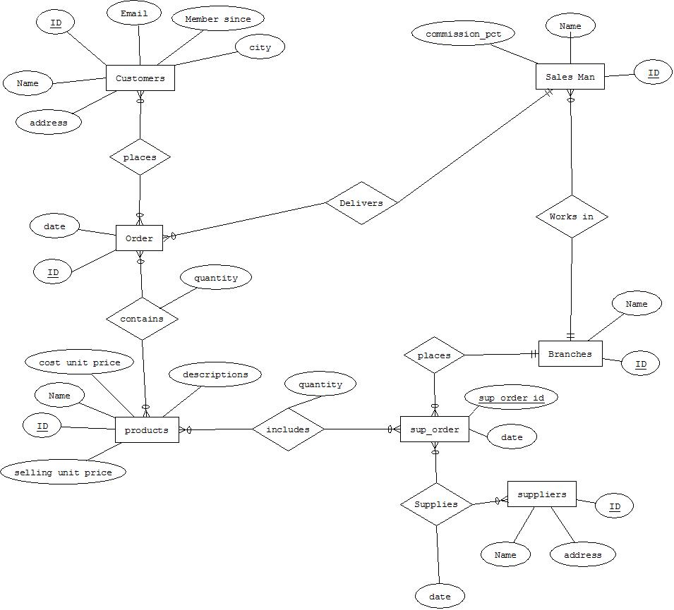

**Normalization**

1. Order

|  |  |
| --- | --- |
| Order_no | Order_date |

1. Places

|  |  |
| --- | --- |
| C_id | Order_no |

1. Customers

|  |  |  |  |  |  |  |
| --- | --- | --- | --- | --- | --- | --- |
| C_id | C_name | C_mobile_no | C_email | Member_since | C_City | C_address |

1. Sales_man

|  |  |  |  |
| --- | --- | --- | --- |
| S_id | S_name | Commission_pct | Br_id |

1. Products

|  |  |  |  |  |
| --- | --- | --- | --- | --- |
| P_id | P_name | Sell_unit_price | Cost_unit_price | P_descriptions |

1. Contains

|  |  |  |
| --- | --- | --- |
| P_id | Order_no | Con_quanity |

1. Suppliers

|  |  |  |
| --- | --- | --- |
| S_id | Sup_name | Sup_address |

1. Supplies

|  |  |  |
| --- | --- | --- |
| Sup_order_id | Sup_id | Sup_date |

1. Sup_order

|  |  |  |
| --- | --- | --- |
| Sup_order_id | Sup_date | Br_id |

1. Includes

|  |  |  |
| --- | --- | --- |
| P_id | Sup_order_id | Inc_quantity |

1. Branch

|  |  |
| --- | --- |
| Br_id | Br_name |

**Relationship diagram**

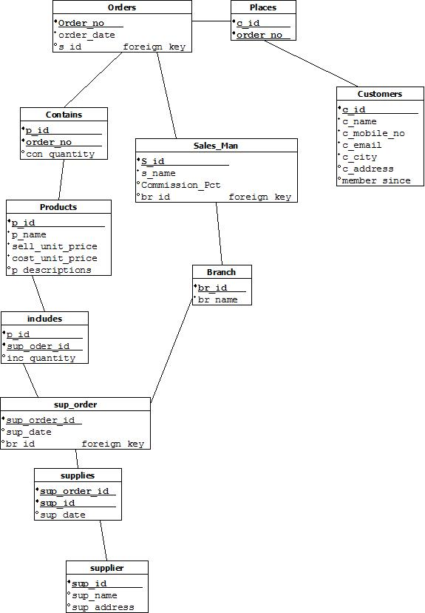

**Screenshots of the table with only data type of the attributes**

**Customers:**

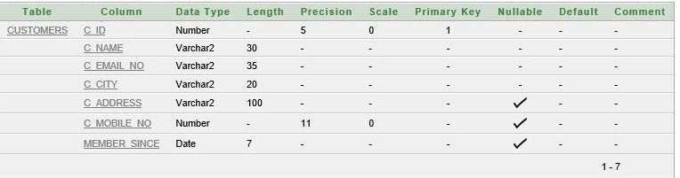

**Branch:**

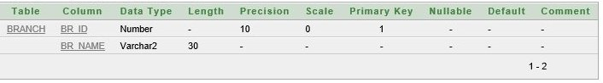

**Places:**

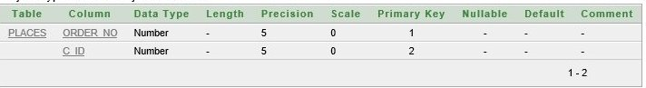

**Orders:**

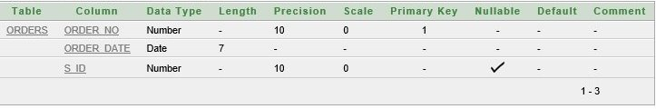

**Contains:**

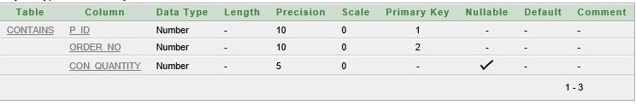

**Products:**

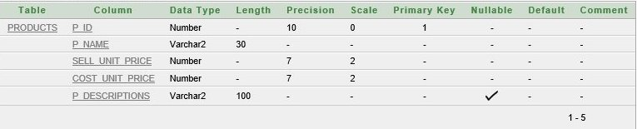

**Salesman:**

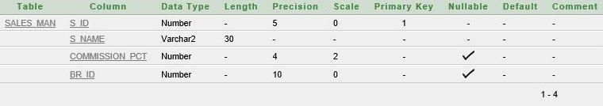

**Supplier:**

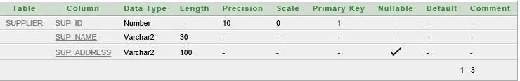

**Supplies:**

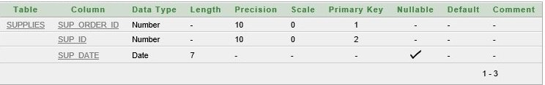

**Sup_order:**

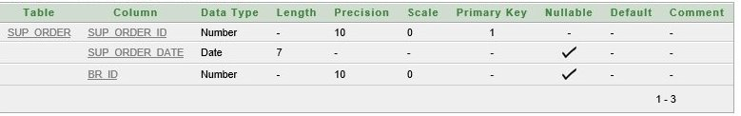

**Includes:**

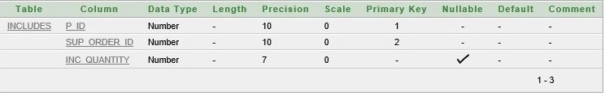

**Screenshot of the tables with sample data records**

**Customers:**

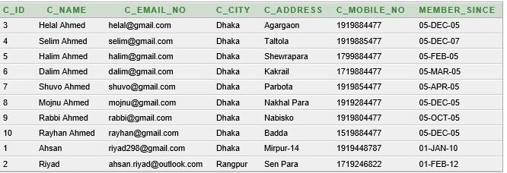

**Places:**

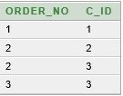

**Orders:**

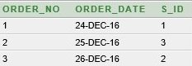

**Contains:**

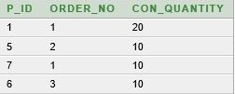

**Products:**

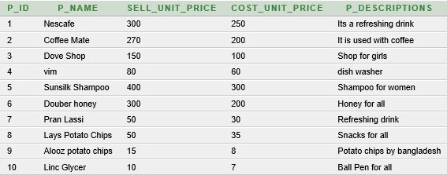

**Supplier:**

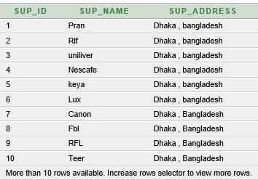

**Sup_order:**

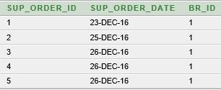

**Supplies:**

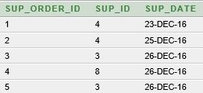

**Includes:**

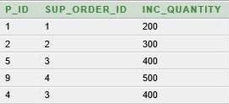

**Branch:**

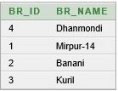

**Sales_man:**

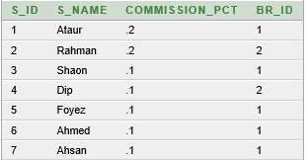

**Demonstrating some database use scenarios and SQL queries**

**1.** Generate a bill for order number 2

*select o.order_no , o.order_date , c.c_id , c.c_name , p.p_id , p.p_name , con.con_quantity , p.sell_unit_price , s.s_id , s.s_name , con.con_quantity*p.sell_unit_price as "Total" from orders o , contains con , sales_man s , customers c , products p , places pl where o.order_no = pl.order_no and pl.c_id = c.c_id and o.order_no = con.order_no and o.s_id = s.s_id and con.p_id = p.p_id and o.order_no = 2*



2. Display total supply of the shop

*select supo.sup_order_id , supo.sup_order_date , inc.p_id , p.p_name , inc.inc_quantity , supplies.sup_date , supl.sup_id , supl.sup_name , br.br_id , br.br_name from products p , includes inc , branch br , sup_order supo , supplies , supplier supl where p.p_id = inc.p_id and inc.sup_order_id = supo.sup_order_id and supo.sup_order_id = supplies.sup_order_id and supo.br_id = br.br_id and supplies.sup_id = supl.sup_id order by supo.sup_order_id asc*

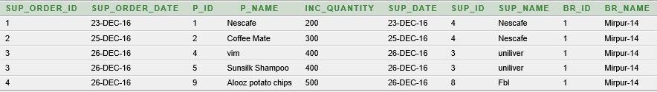

3. Display product supplied , sold and remaing number by Product id

*select c.p_id , sum(c.con_quantity) as "Sold" , sum(i.inc_quantity) as "Supplied" , (sum(i.inc_quantity)-sum(c.con_quantity)) as "Remaining" from contains c , includes i , products p where c.p_id = i.p_id and i.p_id = p.p_id group by c.p_id order by c.p_id*

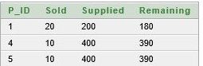

4. Display Maximum selling product by group by Product id

*select c.p_id , max(c.con_quantity) from products p , orders o , contains c where o.order_no = c.order_no and p.p_id = c.p_id group by c.p_id*

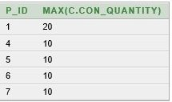

5. Display the sales_id who sold has the highest selling history

*select o.s_id, count(o.order_no) from orders o group by o.s_id order by count(o.order_no) desc*

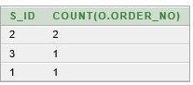

6. Display the most frequent customer id

*select p.c_id , c.c_name , count(p.order_no) as "Total_order" from places p , customers c where c.c_id = p.c_id group by p.c_id , c.c_name order by count(p.order_no) desc*

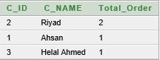

7. Display the mobile number of the customer who id is 2

*select c_id , c_name , c_mobile_no from customers where c_id = 2*



8 . Find the customer name and his sales man name

*select distinct(c.c_name) , s.s_name from customers c , sales_man s , places p , orders o where c.c_id = p.c_id and p.order_no = o.order_no and s.s_id = o.s_id*

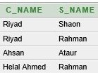

9. Find out goods and quantity which was sold on ‘26-Dec-2016’

*select p.p_name , con.con_quantity from products p , contains con , orders o where p.p_id = con.p_id and o.order_no = con.order_no and o.order_date = '26/dec/16'*

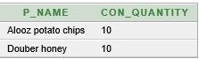

10 . Find out which salesman get .1% commisson;

*select s_name , commission_pct from sales_man where commission_pct = .1*

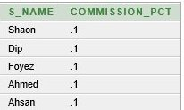

**View creation of the table**

**Complex view:**

1. **SQL Query:** create a view for generating bill

*Create or replace view bill as (select o.order_no , o.order_date , c.c_id , c.c_name , p.p_id , p.p_name , con.con_quantity , p.sell_unit_price , s.s_id , s.s_name , con.con_quantity*p.sell_unit_price as "Total" from orders o , contains con , sales_man s , customers c , products p , places pl where o.order_no = pl.order_no and pl.c_id = c.c_id and o.order_no = con.order_no and o.s_id = s.s_id and con.p_id = p.p_id and o.order_no =*

**Output of the view:** select * from bill;



1. **SQL Query:** create view supply_order so that it shows supply orders

*Create or replace view supply_oder as (select supo.sup_order_id , supo.sup_order_date , inc.p_id , p.p_name , inc.inc_quantity , supplies.sup_date , supl.sup_id , supl.sup_name , br.br_id , br.br_name from products p , includes inc , branch br , sup_order supo , supplies , supplier supl where p.p_id = inc.p_id and inc.sup_order_id = supo.sup_order_id and supo.sup_order_id = supplies.sup_order_id and supo.br_id = br.br_id and supplies.sup_id = supl.sup_id order by supo.sup_order_id asc*

*)*

**Output of the view:** select * from supply_order;



**Simple view:**

1. **SQL Query:** *create or replace view phone_numbe as (select c_name , c_mobile_no from customers )*

**Output of the view:** select * from phone_number;

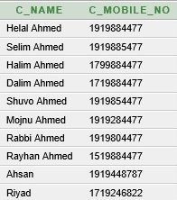

1. **SQL Query:** *create or replace view sman_commission as (select s_name , commission_pct from sales_man)*

**Output of the view:** select * from sman_commission;

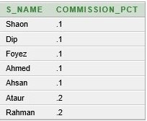

1. **Sql Query :** create or replace view supplier_name as (select sup_name from supplier)

*Select * from supplier_name*

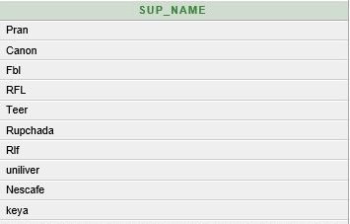

* **Bonus**

**Summarize learning experience from database project**

We have learned many lessons and hade valuable experience doing this project on database system. Though we had several problems doing this project but the achievements were more precious and efficient.

* This project would not be possible without the help of ORACLE SQL APPLICATION EXPRESS software.
* Companies or various institutes use databases because they can store a large number of records, ease of use when locating information, it is easy to add new data and to edit or delete old data, there is ease of storage Data can be imported into other applications
* The whole database model and specially the tables were created very carefully and the joining or linking among the table were done very carefully and also followed DBMS rules
* The constraints such as primary keys or foreign keys of the tables were assigned properly for linking among tables
* By fulfilling these objectives and system policies this project would be a proper and organized database system to run the system.
* The number of levels that the software is handling can be made unlimited in future from the current status of handling up to N levels as currently laid down by the software.
* Efficiency can be further enhanced and boosted up to a great extent by normalizing  and de-normalizing the database tables used in the project as well as taking the kind of the alternative set of data structures and advanced calculation algorithms available.
* We can in future generalize the application from its current customized status wherein other vendors developing and working on similar applications can utilize this system and make changes to it according to their client’s needs.
* Our main outcome would be faster processing of information as compared to the current system with high accuracy and reliability.
* Automatic and error free report generation as per the specified format with ease.
* With a fully automated solution, lesser staff, better space utilization and peaceful work environment, the institute is bound to experience high turnover.
* A future application of this system lies in the fact that the proposed system would remain relevant in the future.

In case there be any additions or deletion of the services, addition or deletion of any individual in any type of modification in future can be implemented easily. The data collected by the system will be useful for some other purposes also.

END**